**Portfolio Task – Scenario 4**

**Introduction**

This Network Routing Principles **Scenarios** are a scaffolded approach to preparing you to succeed in your ultimate **Final Skills Assessments**. The **Scenarios** build on skills from previous **Scenarios** until all required components are covered. **Scenario 4** continues your exploration of alternate routing protocols covered in **Scenarios 1 and 3** and introduces you to a newer – and highly used in the real world – dynamic routing protocol called **Open Shortest Path First** (OSPF).

**Purpose**

In this **Scenario** you will design and construct a network consisting of four routers and two switches. You will reinforce the skills you acquired in building an internal network using a Routing Protocol connected to an external network via a public IP address coupled with ACLs to protect segments of your network. In this Scenario you will be introduced to the **new skill** in the design and deployment of networks running the **Open Shortest Path First** (OSPF)as your routing protocol.

**Methodology**

This portion of the handout contains the necessary information to design and build your network. Information on the assessment is at the end of the handout.

**Network Topology**

The Network topology is displayed in the figure below.

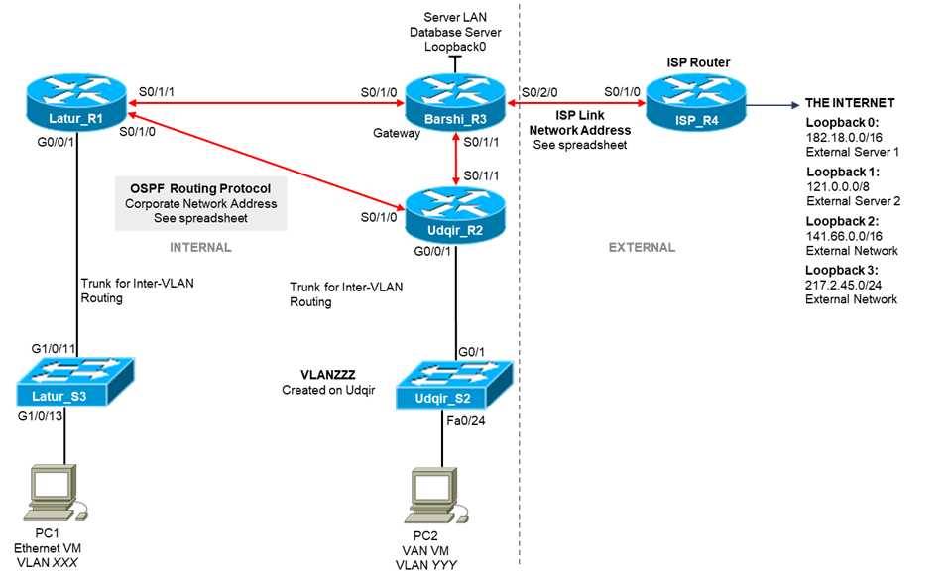

**Network Information**

The Network topology diagram refers to a number of network addresses and VLAN names. Please use the **provided spreadsheet on Canvas** to obtain your personalized network information for **Scenario 4**. The spreadsheet will provide:

* Corporate Network Address
* ISP Link Network Address
* **VLANXXX, VLANYYY,** and **VLANZZZ** VLAN Identification

**Subnetting**

The first task you must perform is to subnet your corporate network to create subnets for your VLANs. The subnetting requirements are:

|  |  |  |  |
| --- | --- | --- | --- |
| **Interface** | **Name** | **IP Address** | **Subnet Mask** |
| VLAN827 | Orange | 145.78.0.1 | 255.255.254.0 |
| VLAN273 | White | 145.78.2.1 | 255.255.255.0 |
| VLAN154 | Grey | 145.78.3.1 | 255.255.255.128 |
| VLAN1 | Latur | 145.78.3.129 | 255.255.255.224 |
| VLAN1 | Udqir | 145.78.3.161 | 255.255.255.240 |
| Internal Serial Link 1 | R1 S0/1/1 to R3 S0/1/0 | 145.78.3.185  145.78.3.186 | 255.255.255.252 |
| Internal Serial Link 2 | R2 S0/1/0 to R1 S0/1/0 | 145.78.3.189  145.78.3.190 | 255.255.255.252 |
| Internal Serial Link 3 | R3 S0/1/1 to R2 S0/1/1 | 145.78.3.193  145.78.3.194 | 255.255.255.252 |
| ISP Link 1 | R3 S0/2/0 | 211.11.53.1 | 255.255.255.252 |
| ISP Link 2 | R4 S0/1/0 | 211.11.53.2 | 255.255.255.252 |
| Database Server LAN | Loopback0 | 145.78.3.177 | 255.255.255.248 |
| Loopback0 | External Server 1 | 182.18.0.1 | 255.255.0.0 |
| Loopback1 | External Server 2 | 121.0.0.1 | 255.0.0.0 |
| Loopback2 | External Network | 141.66.0.1 | 255.255.0.0 |
| Loopback3 | External Network | 217.2.45.1 | 255.255.255.0 |
| PC1 | VLAN827 | 145.78.0.2 | 255.255.254.0 |
| PC2 | VLAN273 | 145.78.2.2 | 255.255.255.0 |
| Default Gateway | Latur | 145.78.0.1 | - |
| Default Gateway | Udqir | 145.78.2.1 | - |

**Basic Network Configuration**

You are essentially rebuilding the network from **Scenarios 2 and 3** except for the routing protocol configuration. In this section will be a brief list of all requirements except for the routing protocol and ACLs. ACLs are configured after the network routing tables are established. Please refer to the previous Scenario Instructions, or more specifically your Lab Journal, if you need assistance in meeting the following requirements.

* Check physical wiring on the devices
* Configure a MOTD and Hostnames on all devices
* Set the MOTD banned to include your student ID, name, and Lab time
* Configure the Switch with an enable password of **cisco,** the necessary VLANs, a management interface on VLAN1, a default gateway, and telnet access with password **cisco**
* Configure Switch ports G1/0/13 and G1/0/14 as access ports on VLANXXX with port security settings of (mac address sticky, max 4, violation protect), and port G1/0/24 as an access port on VLANYYY
* Configure all serial and loopback addresses on routers with interface descriptions
* Configure all routers connected to the switch with inter-VLAN routing using a trunk connection to the switch
* On the ISP router, configure only a static route to the Internal network

Before continuing, you should run all necessary tests to confirm that all the requirements listed above are properly configured.

**Routing Protocol – OSPF**

New tasks in this Scenario include configuring the OSPF Dynamic Routing Protocol instead of RIPv2 or EIGRP. For the most part, configuring OSPF is very similar to the other routing protocols you have already used. OSPF needs to be configured on all internal corporate routers so that routing tables can be updated to self heal.

For this Scenario we will be deploying OSPF. OSPF is the current industry standard routing protocol that is not licensed and is therefore supported on all router brands. Networks with hardware from different vendors can work together using OSPF. OSPF minimizes network traffic if the network topology does not change. OSPF is a more complex algorithm and uses more resources to recalculate routing paths, however it can converge almost as quickly as EIGRP and often makes better routing decisions. OSPF is also more flexible for large networks when using a feature known as Multi-Area OSPF.

The main steps involved in running a OSPF are basically the same as for RIPv2:

1. Enabling the routing protocol
2. Configuring the routing protocol on the router which interfaces and/or networks should be advertised to other routers in the corporate network
3. Validating that the Routing Protocol is properly configured

**OSPF Configuration Information**

In order to enable the OSPF routing protocol on a Cisco router, you need to issue the command:

*router ospf <process_id>*

OSPF can be disabled using the command:

*no router ospf <process_id>*

To add extra configuration to OSPF, you need to re-enter the router *ospf <process_id>* command.

Routers are able to run multiple OSPF networks in parallel with each other. The *<process_id>* field differentiates which – of many – OSPF protocols you wish to configure. The *<process_id>* field does not have to be equal on all routers, it is an identifier only within the router itself. As such, your Scenario will work even if all routers use different values for *<process_id>.* Despite this, it is good practice for networks running only one instance of OSPF to use a *<process_id>* value of **1.**

Specifying which interfaces you wish the OSPF protocol to advertise to other routers is almost identical to EIGRP using both a network address and wildcard mask. However OSPF requires an extra parameter to indicate which OSPF area to advertise the route into. For a single-area OSPF network, you must always use an *<area_number>* of **0.**

*network <network_address> <wildcard_mask> area <area_number>*

The example below will advertise the subnet *186.64.32.0/22* in a single area OSPF network:

*network 186.64.32.0 0.0.3.255 area 0*

As with RIPv2, we will want to have some interfaces configured as passive, the command to do so – *passive-interface <iface_name>* – is exactly the same as for EIGRP and RIPv2. Like EIGRP, OSPF also has the ability to set whether all interfaces on the router should be configured as passive by default. If you wish to do this you can use the command below, and then use the *no passive-interface <iface_name>* command to enable select interfaces.

*passive-interface default*

The command to advertise static routes in OSPF matches RIPv2is different than for RIPv2:

*default-information originate*

Like EIGRP, OSPF uses the configured bandwidth of a link to determine which links are more likely to be chosen when selecting the optimal path through the network. The configured link bandwidth differs from the actual bandwidth and changing this value does NOT reduce or increase the speed of traffic through the link. By default, EIGRP will use the actual link speed for calculations, but this can be changed.

Useful debugging commands include:

*show ip ospf neighbours* – Prints information about directly connected routers running OSPF. This can be useful to determine why routes are not showing as the neighbour is not visible. If this reports that an adjancency is not formed, it is likely that the interfaces on either side of the link do not have matching subnet masks

*show ip ospf database* – Prints information the discovered links in the OSPF database

**OSPF Requirements for Scenario**

For the purposes of the Scenario, you must:

* Run OSPF on all internal corporate routers
* Configure the bandwidth for the point-to-point links between routers as:
  + **Barshi-Udgir** – configure bandwidth 512
  + **Barshi -Latur** – configure bandwidth 128
  + **Latur- Udgir** – configure bandwidth 512
* Advertise all internal network addresses on all internal routers, advertising each subnet individually with an appropriate wildcard mask
* Advertise the default route installed on the gateway router – **Barshi**
* Disable broadcasting on internal edge-networks (all interfaces connected PCs) – all sub- interfaces of **g0/0/1** on **Latur** and **Udgir**

**ACL Requirements for Scenario**

The ACL security requirements for this Scenario are:

Generic ACLs

1. PCs in VLAN XXX **permitted** HTTP access to ISP Loopback 0 and deny ALL other access to this interface.
2. PCs in VLAN XXX **permitted** ALL access to the Internet – all the other Servers.
3. PCs in VLANYYY **denied** PING access to PCs in VLAN XXX
4. PCs in VLAN YYY **permitted** ALL access to the Internet.

Telnet ACLs

1. **ONLY** PCs in VLAN XXX **permitted** TELNET access to **Latur** Router
2. **ONLY** PCs in VLAN XXX **denied** TELNET access to **Barshi** Router